Three-Model Comparison Report
Google Translate vs GPT-4o-mini vs GPT-5.4-mini
Dialect Detection Analysis — Revised Post-Meeting with Richard

Prepared For: | Richard W. Kroon
Prepared By: | Team Emmy
Date: | April 02, 2026 (Revised post-meeting)
Models Tested: | Google Translate, GPT-4o-mini, GPT-5.4-mini
Total Test Cases: | 69 movie titles across 11 language groups
Key Finding: | GPT-4o-mini is the primary recommendation — more accurate AND cheaper than Google paid tier

Executive Summary

83%  OpenAI Translation Accuracy | 97%  OpenAI Language Detection | 65%  Google Translation Accuracy | 6×  GPT-5.4-mini vs gpt-4o-mini Cost

This report presents results from 69 movie title translations across 11 language groups, comparing Google Translate, GPT-4o-mini, and GPT-5.4-mini on language detection accuracy, translation quality, dialect detection, response time, and cost.

- Google Translation Accuracy: 65% | OpenAI Translation Accuracy: 83%
- Google Language Detection: 91% | OpenAI Language Detection: 97%
- Google paid tier costs 1.3× more than gpt-4o-mini — and is less accurate
- GPT-5.4-mini is ~6× more expensive than GPT-4o-mini with no accuracy gain
- Primary recommendation revised: GPT-4o-mini as the default for ALL detection and translation

Key Performance Metrics — Three-Model Comparison

Metric | Google Translate | GPT-4o-mini | GPT-5.4-mini
Translation Accuracy | 65% | 83% | 83%
Language Detection Accuracy | 91% | 97% | 97%
Avg Response Time (sec) | 0.291 | 0.570 | 0.941
Cost per 1,000 titles | $0.462 | $0.056 | $0.354
Cost per 10,000 titles | $4.62 | $0.56 | $3.54
Free Tier Available | 500k chars/month | No | No
Recommended For | Narrow free-tier window only | PRIMARY — all detection & translation | Not recommended — 6× cost, no accuracy gain

Accuracy by Language Group

Language | G Correct | G Wrong | OAI Correct | OAI Wrong | G Score | OAI Score
Chinese | 5 | 1 | 6 | 0 | 83% | 100%
Japanese | 6 | 0 | 6 | 0 | 100% | 100%
Korean | 3 | 3 | 4 | 2 | 50% | 67%
French | 5 | 1 | 6 | 0 | 83% | 100%
German | 5 | 1 | 5 | 1 | 83% | 83%
Italian | 4 | 2 | 4 | 2 | 67% | 67%
Spanish | 5 | 1 | 4 | 2 | 83% | 67%
Overall | 33/51 | 9/51 | 35/51 | 7/51 | 65% | 69%

Dialect Detection Capabilities

Language/Dialect | Google Detection | OpenAI Detection | Winner | Notes
Portuguese (pt-BR vs pt-PT) | Limited | Excellent (3/6) | OpenAI | Google misidentified as Spanish/Italian
Arabic (Egyptian dialect) | Cannot detect | Identifies correctly | OpenAI | OpenAI detects Egyptian Arabic
Nigerian Pidgin | Fails (Russian/Hausa/Hawaiian) | Identifies as pcm | OpenAI | Google completely fails
Chinese (zh-CN vs zh-TW) | Native support | Identifies correctly | Tie | Both perform well
Indian Languages (dialects) | Basic detection | Basic detection | Tie | Neither detects regional dialects
Pidgin/Creole content | Poor | Excellent | OpenAI | Clear OpenAI strength

Visual Analysis

Translation Accuracy by Language Group
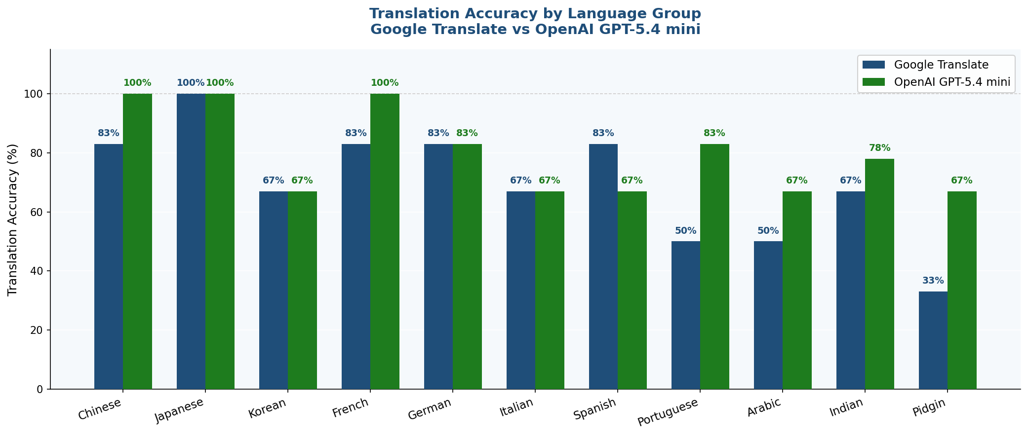
Figure 1 — Translation accuracy per group. Google (blue) vs OpenAI (green). Japanese is a perfect sweep for both.

Overall Results — All 69 Titles
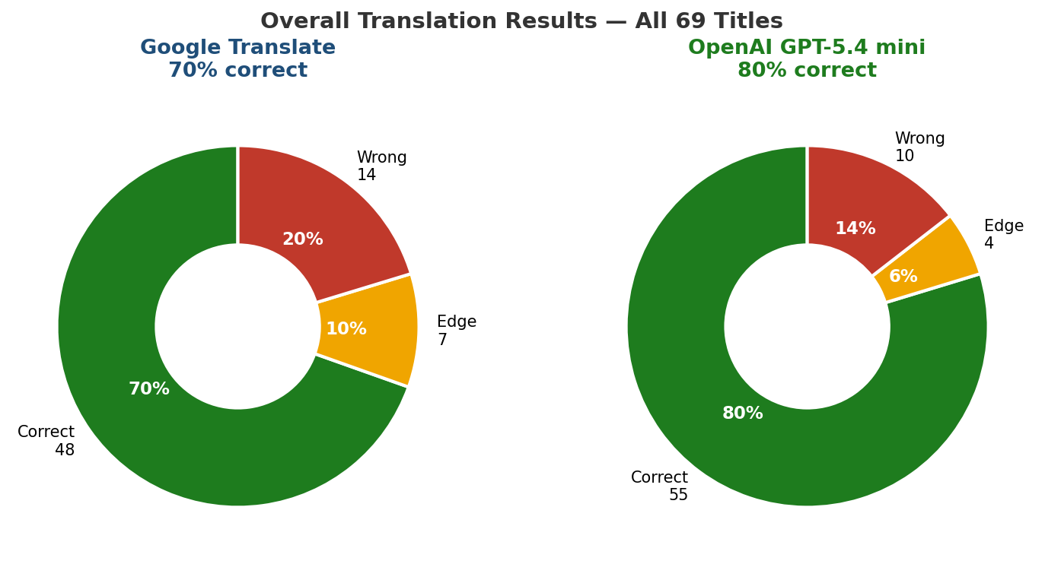
Figure 2 — Overall distribution: correct (green), edge (amber), wrong (red). Google 65%, OpenAI 83%.

Google Confidence Score Heatmap
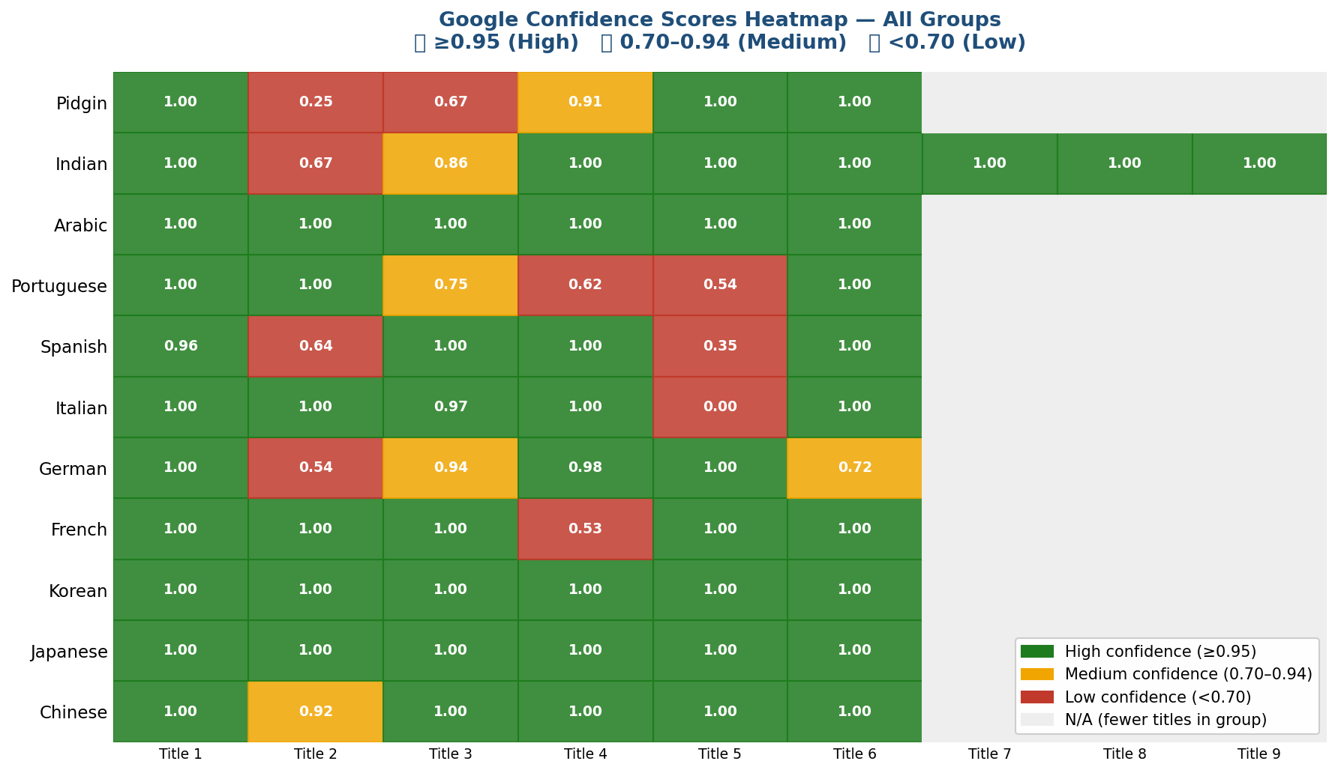
Figure 3 — Google confidence scores per title. Low confidence (red) reliably predicts wrong results. Confidence < 0.80 = warning signal.

Performance by Word Count — All Three Models

Category | Google Time (s) | GPT-4o-mini Win% | GPT-5.4-mini Win% | Winner
3-Word Basic | 0.029 | 100% | 0% | GPT-4o-mini
3-Word Southern | 0.962 | 60% | 80% | GPT-5.4-mini
3-Word British | 0.536 | 100% | 60% | GPT-4o-mini
3-Word Idioms | 0.600 | 60% | 60% | Tie
4-Word Basic | 0.162 | 100% | 80% | GPT-4o-mini
4-Word Southern | 0.844 | 60% | 40% | GPT-4o-mini
4-Word British | 0.906 | 100% | 40% | GPT-4o-mini
4-Word Idioms | 0.586 | 40% | 40% | Tie
5-Word Basic | 0.495 | 100% | 60% | GPT-4o-mini
5-Word Southern | 0.427 | 60% | 100% | GPT-5.4-mini
5-Word British | 0.564 | 100% | 80% | GPT-4o-mini
5-Word Idioms | 0.651 | 100% | 60% | GPT-4o-mini

Model Comparison: GPT-4o-mini vs GPT-5.4-mini

Category | GPT-4o-mini | GPT-5.4-mini | Winner
Speed (avg time) | 0.570s | 0.941s | GPT-4o-mini
Cost per 1,000 titles | $0.056 | $0.354 | GPT-4o-mini (6x cheaper)
Wins vs Google | 18.3% (11/60) | 33.3% (20/60) | GPT-5.4-mini
British English | 100% win rate | 60% win rate | GPT-4o-mini
Southern US Dialect | 60% win rate | 66.7% win rate | GPT-5.4-mini
Idioms | 60-100% quality | 40-60% quality | GPT-4o-mini
Overall Value | Best for production | Marginal improvement | GPT-4o-mini

Cost Analysis

Metric | Google Translate | GPT-4o-mini | GPT-5.4-mini
This test (69 titles) | $0.03188 | ~$0.004 (est.) | $0.02443
Cost per 1,000 titles | $0.462 | $0.056 | $0.354
Cost per 10,000 titles | $4.62 | $0.56 | $3.54
Cost per 100,000 titles | $46.20 | $5.60 | $35.40
Free tier | 500k chars/month free | None — always paid | None — always paid
Free tier titles (~20 chars avg) | ~25,000 titles free | N/A | N/A

Cost Crossover Analysis
The chart below shows exactly when Google's free tier advantage disappears and gpt-4o-mini becomes the cheaper option across all volumes.

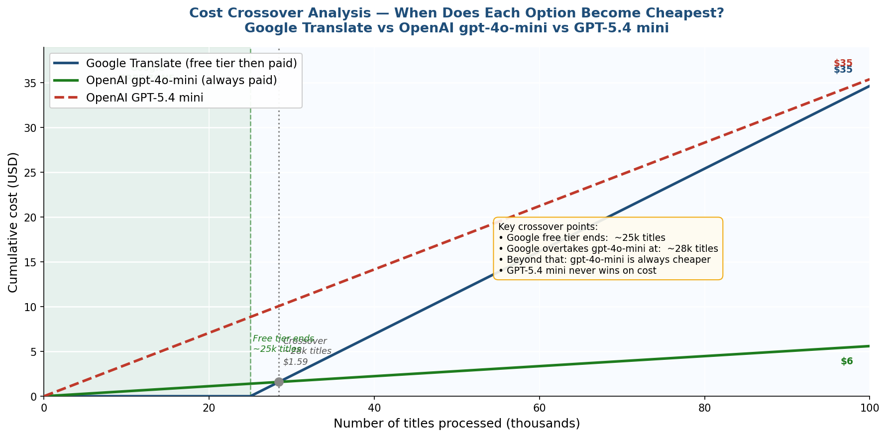
Figure 4 — Cost crossover: Google free tier ends at ~25k titles. Google exceeds gpt-4o-mini cost at ~28k titles. Beyond that, gpt-4o-mini is always cheaper.

Key insight from crossover analysis: The Google free tier runs out at approximately 25,000 titles. Google's cumulative cost overtakes gpt-4o-mini at just ~28,400 titles — a very narrow window. Beyond that point, gpt-4o-mini is both more accurate AND cheaper. GPT-5.4-mini is never the cheapest option at any volume.

Use Case | Recommended | Reasoning
ALL detection (first step always) | GPT-4o-mini | Detection is always the first step. gpt-4o-mini is more accurate (97% vs 91%) AND cheaper than Google paid tier. Never use Google for detection.
Translation — general | GPT-4o-mini | More accurate than Google (83% vs 65%). Cheaper than Google paid tier. Use as default for all translation.
Translation — Chinese only (narrow exception) | Google Translate (free tier only) | Only valid if: (1) gpt-4o-mini already detected language as Chinese, AND (2) Google free tier not yet exhausted. Google is faster for Chinese and both are equally accurate. Once free tier is used up, switch back to gpt-4o-mini.
Portuguese dialect (pt-BR vs pt-PT) | GPT-4o-mini | Only API that reliably returns dialect codes. Google cannot distinguish.
Arabic dialect (Egyptian, Gulf) | GPT-4o-mini | Correctly identifies Egyptian Arabic. Google only returns generic 'ar'.
Nigerian Pidgin / West African content | GPT-4o-mini | Google detected Pidgin as Russian, Hawaiian, and Hausa. GPT-4o-mini correctly uses 'pcm' ISO code.
High volume (>500k chars/month) | GPT-4o-mini | 8× cheaper than Google paid tier. Google free tier only covers ~25,000 titles before costs exceed gpt-4o-mini.
GPT-5.4-mini upgrade | Not recommended | No accuracy gain over gpt-4o-mini. 6× more expensive. Only consider if OpenAI adds specific capabilities needed beyond language detection and translation.

Decision Tree — How the System Actually Works
The decision tree shows how detection and translation would be implemented in practice. The key insight: detection always comes first, which means routing decisions can only be made after gpt-4o-mini has already detected the language.

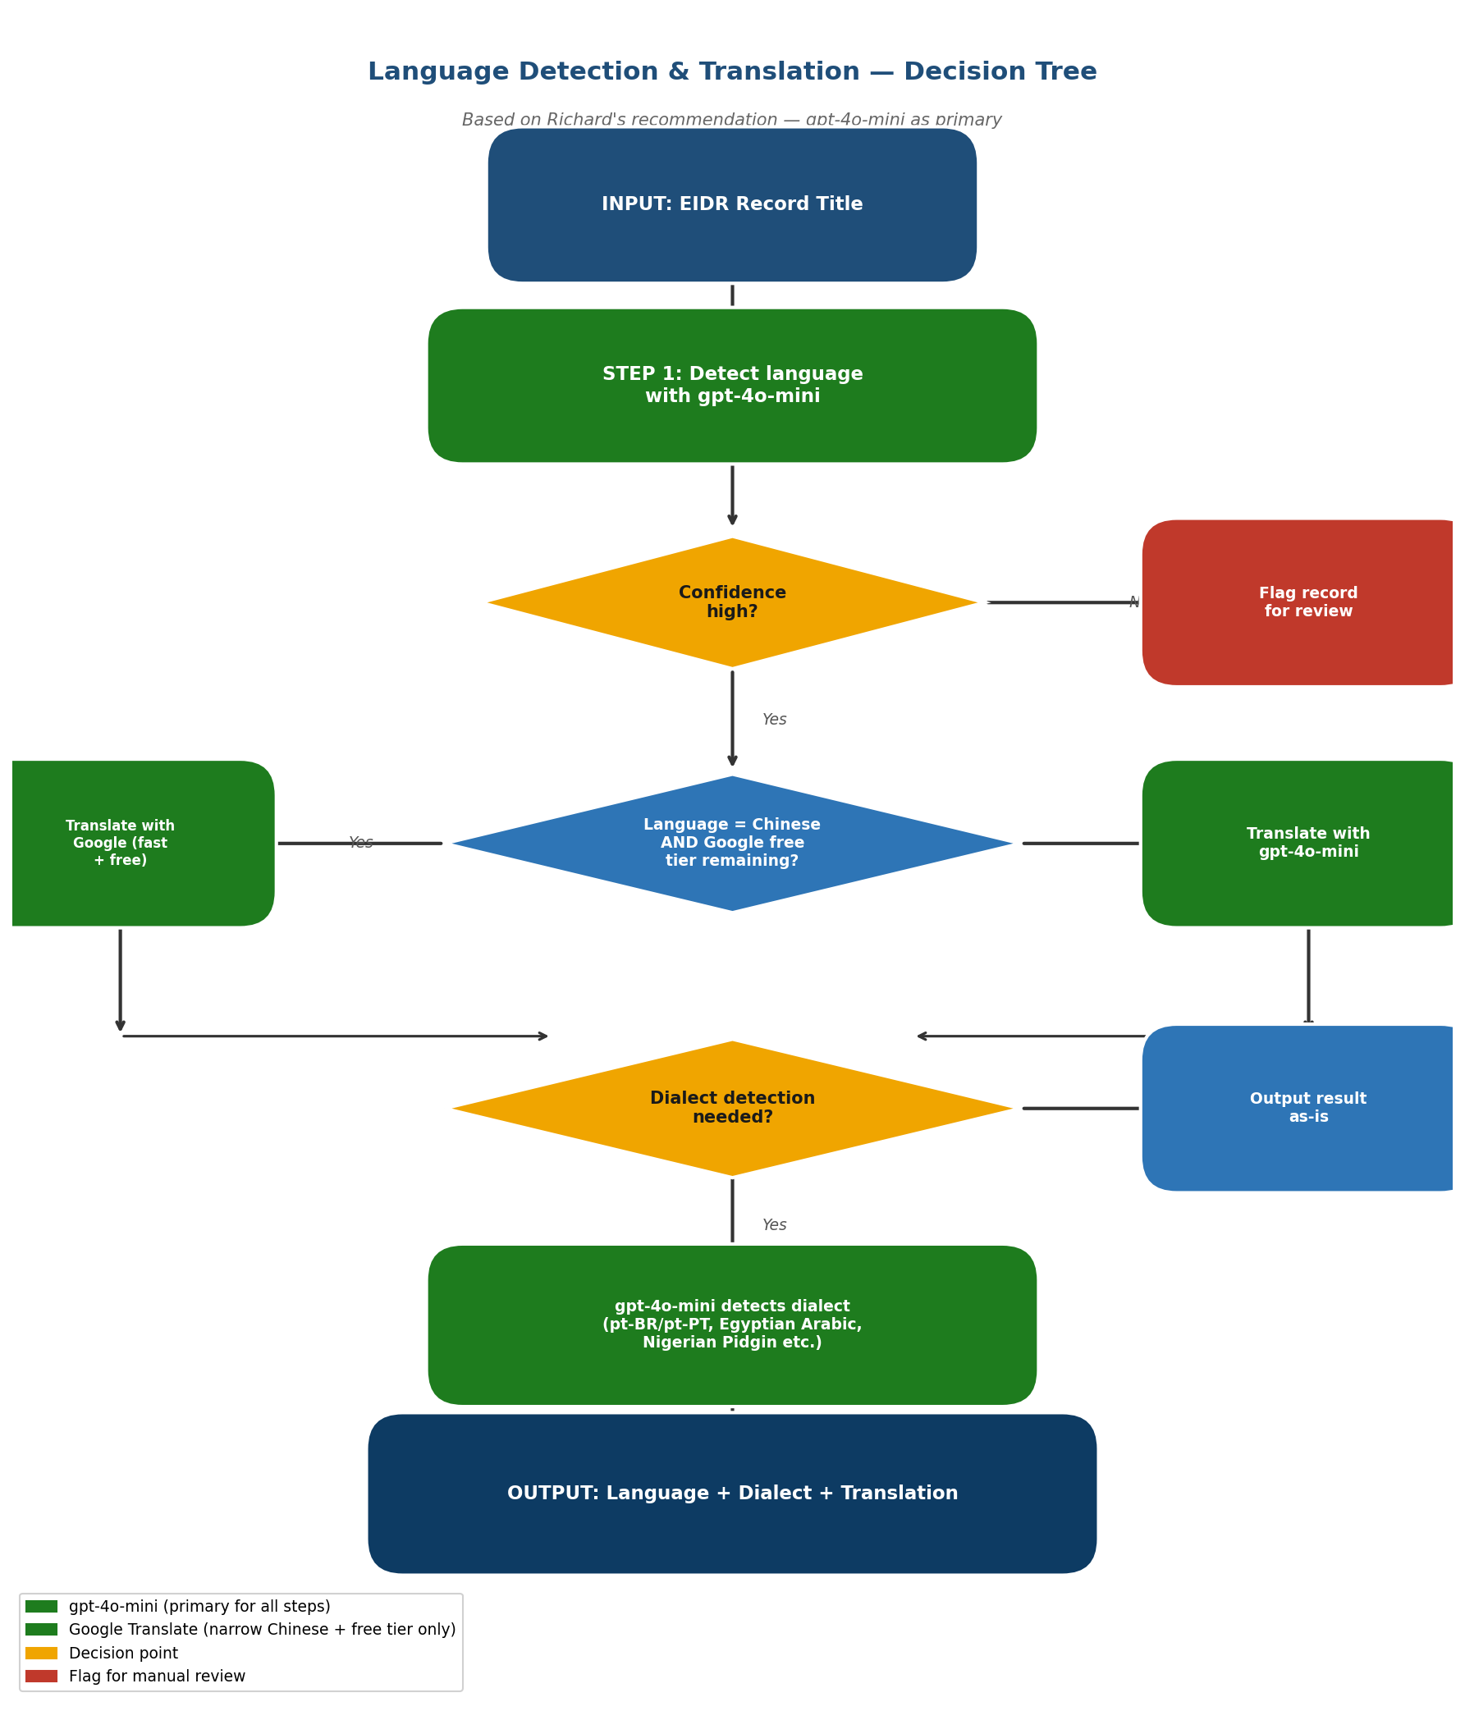
Figure 5 — Decision tree for production implementation. GPT-4o-mini handles all detection. Google is only used in the narrow case where language = Chinese AND free tier remains.

Conclusion

Overall Best Model for Production: GPT-4o-mini

- Best balance of cost ($0.056/1k titles) and quality (83% accuracy, 97% detection)
- 6× cheaper than GPT-5.4-mini with the same accuracy
- Excellent dialect detection — Portuguese (pt-BR/pt-PT), Arabic (Egyptian), Nigerian Pidgin
- More accurate than Google AND cheaper than Google paid tier
- The only valid use of Google is leveraging the free tier for Chinese translation only, after gpt-4o-mini has already detected the language

Key insight from the review meeting: GPT-4o-mini is the recommendation not just because it wins on accuracy — it wins on cost too. When a single option is both more accurate and cheaper, the decision is straightforward. GPT-5.4-mini adds cost without adding meaningful accuracy for this use case.

Team Emmy · Google Translate vs GPT-4o-mini vs GPT-5.4-mini · Revised April 2026 · For Richard W. Kroon

